Name: [type name here]

Short answer questions. Each question’s value is indicated in points. Make sure to answer all questions in complete sentences and are grammatically correct statements.
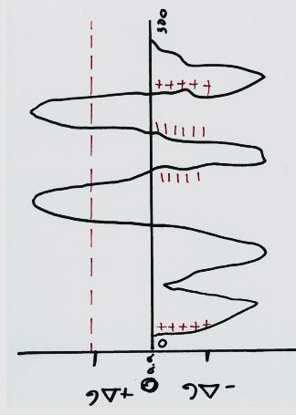
Membrane protein orientation. I have drawn a hypothetical membrane protein that has a hydrophobicity plot. Please answer the following questions about the protein’s predicted structure. Each question has two parts, make sure to answer both!

1.) How many transmembrane domains does the protein have? Tell me what part of the plot allows you to determine the number of transmembrane domains. 4pts
The protein has two transmembrane domains which represent the transmembrane portions. The two portions of the hydrophobic part of the y-axis (+∆G) represent the portions which span the hydrophobic part of the membrane, labeled with the two blue stars.
It is the hydrophobic part of the plot that enables you to know the transmembrane domains.

2.) Where is the N-terminal part of the protein found? What charge allows you to determine the orientation of the N-terminus? 4 pts
The N-terminal (amino terminal) is located in the hydrophilic cytoplasm (extracellular fluid). The orientation of the N-terminus is determined by the positive charges.

3.) Where is the C-terminal part of the protein found? What charge allows you to determine the orientation of the C-terminus? 4pts

The C-terminal (carboxyl terminal) is also found on the extracellular matrix (cytoplasm). This follows a general rule which states that with an even number of transmembrane domains, the amino and carboxyl groups of a transmembrane protein are located on the same side.
The orientation of the C-terminus is determined by the negative charge.

The Nuclear Localization Signal (NLS) was discovered to play a role in protein import into the nucleus. Two different experiments were performed to demonstrate that the NLS was both necessary and sufficient for protein localization inside the nucleus.

4.) Explain the experiment that was performed to demonstrate that the NLS is necessary for import into the nucleus. Include the control and experimental 'sample'. 6pts
Nuclear Localization Signal is important for the transportation of proteins into the nucleus. Importins identify the NLS and thus bind with the protein being transported in a series of reactions. And with the help of Ran-GTP the molecule is transported into the nucleus.
In the first experiment, scientists altered the amino acid sequence of the Nuclear Localization Signal as shown below;
Original sequence- Pro– Pro– Lys– Lys– Lys– Arg – Lys– Val–
Altered Sequence- Pro– Pro– Lys– Thr – Lys– Arg – Lys– Val
As a result, at the end of the experiment, the protein with the original NLS was found to have been transported into the nucleus while the protein with the modified NLS was still located in the Cytoplasm, not transported. This demonstrated that the NLS was necessary for the transport of the proteins.
The original sequence NLS acted as a control experiment.

5.) Explain the experiment that was performed to demonstrate that the NLS is sufficient for import into the nucleus. Include the control and experimental 'sample'. 6pts
To demonstrate that the NLS was sufficient, recombinant DNA techniques were used to add NLS molecules to a dummy protein. Normal bovine serum albumin (control) was injected through micropipettes into a hapless cell together with modified bovine serum albumin in which NLS was added.
Both molecules were efficiently transported into the nucleus due to the NLS which were added. Under normal circumstances such transport wouldn’t have been possible. This demonstrated that the NLS is sufficient for importing proteins into the nucleus.

6.) X-chromosome inactivation is a complex stepwise process. Describe the process on how an X-chromosome is inactivated. 4pts
X chromosome inactivation occurs in females so as to ensure both males and females have equal expressions of the X chromosomes (considering women have two x chromosomes and men one x chromosome).
In the first step, the random x inactivation process requires a gene called XIST which encodes a large non-coding RNA.
The RNA then accumulates in the chromosome containing this active XIST gene. After accumulating, this gene inactivates almost every other gene in that particular X chromosome in the nucleus. However, The RNA does not affect the other X chromosome which does not have the active XIST gene. This happens in the egg cell and is irreversible therefore successfully preventing overexpression of the genes in the X chromosomes. The inactivated chromosomes form what is called barr bodies which are later condensed in another process.



7.) Why are calico cats only female?
How do you get the calico coat pattern? 5pts
The calico cats (tricolored cats) are always female due to the gene locus controlling color being on the X chromosome. The colors in question are normally black and yellow. Since the female cat has two X chromosomes the calico color pattern will occur if the genes for black and orange color are in the two x chromosomes which a female cat has. However, this will not happen for a male cat as it has only one x chromosome hence can either be black or orange.
If a black male cat mates with an orange female cat, since it gives the y chromosome to form a male offspring, the offspring will bear the color of the mother, orange. However the female offspring will be calico. Conversely for an orange male black cat and a black female cat, the male offspring will be black while the female calico.
The calico color pattern occurs very rarely in some male cats of XXY genome. The gene for white coat is usually on another chromosome hence the white coat may or may not be present in a calico cat.

8.) What is an aquaporin? What does it transport? How is it specific for that molecule and doesn’t other ions or molecules pass through the aquaporin? 3pts
An aquaporin is a transmembrane protein which facilitates faster movement of water molecules through the cell membranes in a single file, without energy, while limiting other charged molecules.
Aquaporins transport water molecules.
Aquaporins allow water molecules to pass through but not other charged particles as the narrow passage way of the aquaporin is positively charged (due to alignment of the amino molecules) hence very hydrophilic. Thus positively charged protons including H+ ions are actively repelled and cannot go through the Aquaporin.

9.) What is a facilitative transporter? What is an example of one that we went over? 2pts
These are integral (transmembrane) proteins that transport large solutes that are normally impermeable in the cell membranes along a concentration gradient.
Glucose transporter is an example of such a transporter.

10.) What is indirect active transport? What are the two types that can occur? What directions are the molecules going in both types? 5pts
Indirect active transport is a way through which molecules are moved against a concentration gradient by being coupled to an ion which is being transported downhill through a symport protein. Mostly glucose is transported against its concentration gradient by being coupled to sodium ions. Later the sodium ion is transported out of the cell through the Na+/K+ Atpase.
Two types can occur: Symport pumps- where the molecule, mostly glucose coupled to the sodium ion, moves in the same direction i.e. into the cell.
Antiport pumps; where the sodium ions diffuse through the pump and in the process, providing energy for the transport of the other molecule to the opposite direction.

11.) What are the 3 types of membrane proteins? Where are they located in relation to a membrane? 3pts

Integral proteins (motopic and transmembrane); Monotopic proteins are attached to one of the leaflets of the phospholipid bi-layer. The proteins which span across the entire cell membrane to emerge on the other side are known as the transmembrane proteins.
Peripheral proteins; these are attached on the surface of the cell membrane.
Lipid anchored proteins; these are proteins covalently attached to lipids that are embedded in the lipid bi-layer.

The H⁺/K⁺ATPase is found in the stomach and plays a role in the transport of H⁺ and K⁺ between the lining of the stomach and the contents of the stomach.
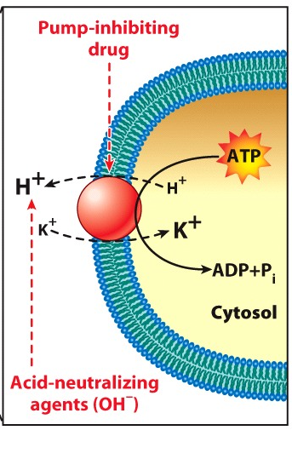
To the left you have used a drug that inhibits the activity of the H⁺/K⁺ATPase.

12.) Describe what the normal balance of H⁺ and K⁺ in an untreated cell would be. e.g. tell me where there would be a high concentration of each ion. 2pts

Hydrogen ion concentration is more inside the cell while the potassium ion concentration is more outside the cell, that is, in the stomach.

13.) Then when you add the drug, tell me how the concentration of both ions (H⁺ and K⁺ ) will change. 2pts
On addition of the drug the transport of K+ ions into the cell and H+ ions into the gastric mucosa is impeded hence more H+ ions will remain in the cell and more K+ ions will remain outside the cell reducing the acidity in the stomach.

